MWEMBEZHI SECONDARY SCHOOL
CHEMISTRY LESSON PLAN
GRADE | TOPIC | SUB TOPIC | DURRATION | DATE
11 | mole | Molar concertartion | ____min | ____/___/__

RATIONALE: concentration is the amount of substance that is dissolved in a given volume of liquid is known as the concentration of the liquid. It will help the learners to determine the concentration of substance. Group/ pair work and demonstration will be used to execute the lesson.
SPECIFIC OUTCOMES, LSBAT: - Determine the concentration of a solution and apply dilution
law.
- Appreciate that the number of moles of solute before dilution is the same as after dilution, M1V1 = M2V2.
- Use the formula below to find the concentration of substance.
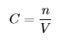

PRE-REQUISITE SKILLS : learners have knowledge on how to calculate the
volume of substances.
TEACHING/ LEARNING AIDS : chemistry key points pupils book 11, periodic table.
REFFERENCES : chemistry 11
LESSON PROGRESSION
STAGE | T/L ACTIVITY | LEARNING POINTS
INTRO-  DUCTION  ____min | Revise on how to find the number of moles of an element and compounds.
D  E  V  E  L  O  P  M  E  N  T  ____min | ACTIVITY 1  What is concentration  EXAMPLE  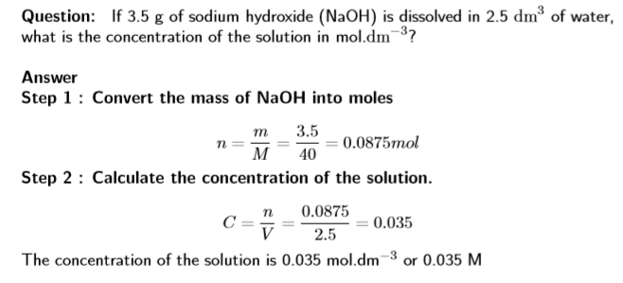  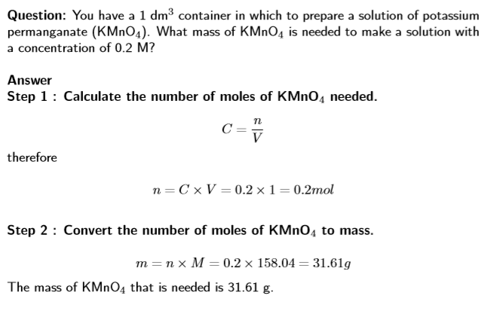  EXAMPLE | Concentration is a measure of the amount of solute that is dissolved in a given volume of liquid. It is measured in mol.dm−3.  C = concentration of the solution in (mol.dm-3)  n = amount of solute (mol)  V = volume of the solution (dm3)
C  O  N  L  U  S  I  O  N  ____min | exercise  What is the molarity of the solution formed by dissolving 80 g of sodium hydroxide (NaOH) in 500 cm3 of water?

